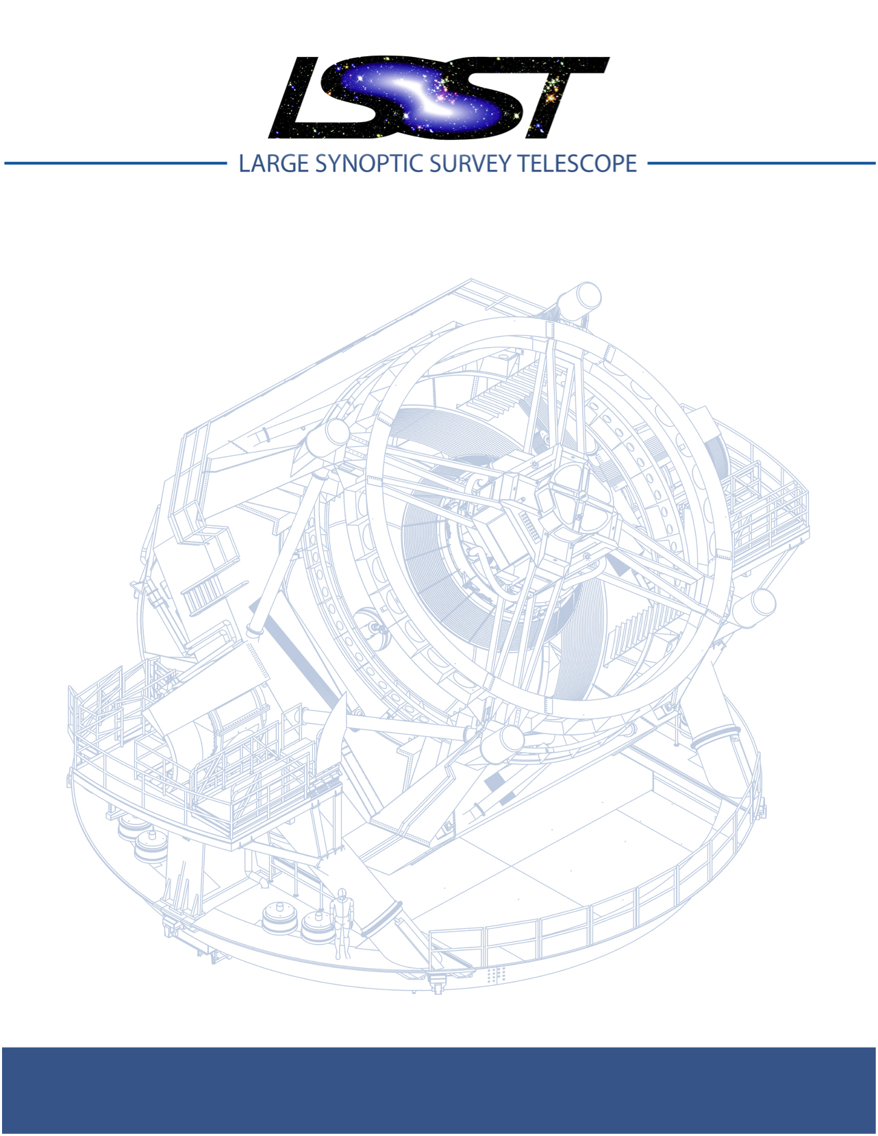

Large Synoptic Survey Telescope (LSST)
T&S Optical Test Plan

Sandrine Thomas, Constanza Araujo, John Bagnasco, Chuck Claver, Doug Neill, Jacques Sebag, Bo Xin

Document-29054

Latest Revision: May 17th, 2018

This LSST document has been approved as a Content-Controlled Document. Its contents are subject to configuration control and may not be changed, altered, or their provisions waived without prior approval. If this document is changed or superseded, the new document will retain the Handle designation shown above. The control is on the most recent digital document with this Handle in the LSST digital archive and not printed versions.

Change Record
Version | Date | Description | Owner name
1 |  | Initial release | S. Thomas
2 |  | 2nd workshop | S. Thomas

Change Record 1
1 Context 4
2 Optical Tests at the vendor/before shipping to Chile 5
2.1 M1M3 tests in Tucson 5
2.1.1 Surface Error Quality 5
2.1.2 FEA Model Validation 5
2.1.3 Look-Up-Tables 6
2.2 M2 tests at Harris 6
2.2.1 Surface Error Quality 6
2.2.2 FEA Model Validation 6
2.2.3 Look-Up-Tables 7
3 Mechanical tests before optics installation 7
3.1.1 Measurement of a group of points with the Laser Tracker 7
3.1.2 Measurement of a single point with the Laser Tracker (not time) 7
3.1.3 Measurement of a circle with the Laser Tracker 7
4 M3 Optical Tests at the summit in Chile 8
4.1 Tests pre-installation on the telescope 8
4.2 Tests on of M1M3 surrogate with the TMA 8
4.3 Preparation of the M1M3 real mirror 8
4.4 Real M1M3 mirror on the telescope 8
5 Three mirrors testing on sky, on axis 9
5.1 Alignment of the IOTA 10
5.2 Built and refine the telescope pointing 10
5.3 Look-Up-Table Tests 11
5.3.1 Prerequisites 11
5.3.2 Measurement Goals 11
5.3.3 Procedure for the Look-up-Table verification 11
5.4 AOS pipeline verification (if time permits) 12
5.5 Cross check of the wavefront measurement between SHWFS and curvature at different elevations. 12

T&S Optical Test Plan

Context
Telescope and Site (T&S) is responsible for the Optical System from the entrance of the telescope up to the camera entrance. This includes an 8.4m primary mirror, a 3.4m M2 mirror and a M3 mirror, with M1 and M3 made out of a single piece of glass.
Each mirror is equipped with actuators to allow to do active optics correction as a function of elevation angle, azimuth angles and temperature. In addition, the camera will provide wavefront feedback thanks to wavefront sensors located on the periphery of the detector.
The T&S group is responsible for the delivery of the 3 mirrors system image quality defined by the error budget.
The deliverables from the T&S group are:
- As built surface error quality
- Operational Look-up-Tables (AOS open loop)
- AOS closed loop
  - First order bending modes reproducibility
  - A reliable FEA model (influence matrix, repeatability)
  - Optimization of penalty matrix and feed-forward
- Model based corrections
  - Off axis field distortion
  - Mechanical FEA
  - Thermal FEA
  - Ray-traced based sensitivity matrix

The optical plan has 3 different phases:
- Optical tests at vendor
- Optical tests on telescope
- Optical tests with the 3 mirrors system which can further be decomposed in 3 steps:
  - On axis
  - ComCam
  - LSST Cam

Optical Tests at the factory before shipping to Chile
The goal of this phase is to get a good set point for each of the 2 optical subsystems before installing on the telescope The tests done before shipping to Chile focus on the mirror surface error, the FEA model and correctability.

M1M3 tests in Tucson
For more detailed tests, please refer to LTS-506.

Surface Error Quality
The mirror M1M3 was polished with a fixed support, using a calculated force sets that would minimize the stress on the glass. The optimal force distribution was calculated from the FEA model. The obtained shape was then measured with 2 interferometers placed at the focus of M1 and the focus of M3. The tests were done at Zenith. https://docushare.lsst.org/docushare/dsweb/View/Collection-3272
Around November 2018, the mirror is planned to be assembled with its cell manufactured by both CAID and the LSST team. At this point the M1M3 system (the mirror in its cell) will be placed in the Mirror Lab test tower, with an interferometer at each focus to allow for simultaneous measurements.
The first test is to verify the surface quality using the calculated set of forces on the mirror. The expectation is that the 20nm requirement will be met as well as the structure function. In the case it does not, there will be a need for an optimization of the force distribution based on the required surface quality. The optimization is done by calculating the influence functions (see section below) then re-optimize the forces, put the optimized forces in the FEA model.
All the tests in the mirror lab are done at a constant temperature of 20C +/- 2 C.

FEA Model Validation

Influence Functions
For the influence functions the procedure is as follow:
- Measure the influence function by poking one actuator at a time. The different positions for the actuators will be 0,+X,0,-X ,0. The time estimation of this measurement is 1/2 day depending on the settling of actuators (TBR). The software to convert the interferograms to surface maps is needed.
- Compare the measured surface maps to the ones obtained using the FEA model at a temperature of T=20C. The FEA model optimization will be required for some of the influence functions.
As far as repeatability is concerned, we most likely will not need several measurements at each positions (TBC). Indeed, the interferometer does take an average for each measurement. In addition, there will be reproducibility from the actuator tests at CAID. Finally reinstallation of actuator repeatability is also done at CAID.

Bending Modes
The procedure to measure the bending modes is as follow:
- Measure individual bending modes at zenith. The goal is to measure the first 22.
- The measurement will then be compared to the current FEA model
- If needed, update the FEA model
Another test needed to verify the FEA model and help the AIV/Commissioning teams understand some of the upcoming interferometric measurements done in Chile is the following:
- Apply the bending modes that would be needed to correct for its position at horizon and other elevation in within the capture range of the interferometer.
- Measure the surface to validate it’s the expected one from FEA in within 20nm.
- Tweak the FEA model if needed (Any other checks needed?)
- Validate the bulk property of the FEA model

Hysteresis
In order to check for hysteresis, we will need to apply the optimal forces at different time and coming from different positions. (TBR)

Look-Up-Tables
The Look-up-Table at this stage is defined from the FEA model. There is only one data point – one temperature and one axis -- to verify the model.

M2 tests at Harris

Surface Error Quality
The polishing of the M2 mirror is done with active actuators. The surface quality is measured using an interferometer with M2 looking down to mimic the configuration at the summit. The figure error is kept under 13nm. The process is iterative. They re-optimize the actuator force set using the FEA model and then polish the mirror with the calculated optimized set of actuators forces.
The temperature is 20C (TBC)

FEA Model Validation
The validation of the FEA model is done using three bending modes: Coma, Power and Trefoil. The influence matrix comes from the FEA. The requirement on the accuracy of the measure bending modes is to be within XX nm of the calculated ones.
Potential measurement for Harris: measure at zenith the expected shape of the mirror defined for a certain high zenith angle to verify that the mirror can reach that shape with high accuracy. Most likely not going to happen

Look-Up-Tables
The Look-up-Table at this stage is defined from the FEA model. There is only one data point – one temperature and one axis -- to verify the model.

Mechanical tests before optics installation

Measurement of a group of points with the Laser Tracker
This use case is the main use case associated with the survey mode of operation. The laser tracker measures a lot of points, fits a circle to it and defines the optical axis and the plan of reference. The goal is to then measure the position (decenter, tilt and focus) of the M2 and the instrument relative to M1M3 location.

Measurement of a circle with the Laser Tracker
The measurement of a circle will be used for instance to characterize of the behavior of the telescope as a function of temperature. The procedure is to calibrate the position of the SMRs for different temperature and compare the measurements with the FEA model.

M3 Optical Tests at the summit in Chile

Tests pre-installation on the telescope
The mirror M1M3 will undergo minimal integration before going through the washing station and the coating chamber. It is only after that the actuators will be installed.

Tests on of M1M3 surrogate with the TMA
These tests will be conducted using the surrogates for the top end. The goals for this step are:
- Interfaces checks between the TMA and the M1M3 cell.
- General dynamic testing. The aim is to measure the sensitivity of the coupling between the TMA and M1M3 while slewing and settling. The procedure is to set the jerk coefficient set to 0 on the mount control (hard acceleration) and look at the impact of the jerk on the actuators. This is done by measuring the fundamental frequency of the mirror from the load cell response. (note: we can not go faster cause of the limit of the pneumatic and we can not go slower due to the requirements on the slew speed)
- Static support position checks looking at the height with the laser tracker

Preparation of the M1M3 real mirror
The telescope is back at Zenith and the cell with the surrogate is removed from the telescope. Down at the 3rd floors, we need to undo actuators, pull surrogate off. The preparation of the mirror lift and the vacuum lift (contract from the mirror lab) will include:
- We do need to apply a fresh Opticoat before lifting. There are some cautious to be taken due to toxic paint. This step will take around 2 days
- Static support position checks heights with the laser tracker. We want to test the heights because the mirror should then be on the cell for 30 years at this point
- Move to the cell using the static support.
- Remove the Opticoat.
- Once ready, the mirror is sent to the washing station again and then the coating chamber. The coating is done with the minimum actuators
- Once coated, put the fan units in and the rest of the actuators with transport cover

Real M1M3 mirror on the telescope
At this stage, the real M1M3 mirror system is installed on the telescope. The goal of the tests includes:
- refinement of the active thermal system using the thermocouples from M1M3
- measure the surface quality of the mirror.
The telescope will have the real M1M3 mirror system and the real M2 and will be pointed at horizon. Because of the need to measure M3 independently from M2, the plan is to use an interferometer and because of required compromises between cost and schedule we will limit the tests at horizon. The compromise will be to increase the list of tests done with the high speed camera (see section XX).
The exact details for the use of the interferogram are still in the work. For instance there is a need for a lock out procedure before removing the integrating structure and align the interferometer. Also there are uncertainties on how to to hold the interferometer. Ask Gary for help on the test setup
Once aligned, the interferometer is used to measure the surface quality as follow:
- Apply the LUT for horizon pointing
- Verify it’s in the capture range of the interferometer.
  - If not it could be a misalignment of the hologram (this will be first aligned to the interferometer looking at the out ring reflection back to the interferometer)
  - Move the hologram + interferometer to align to the mirror by looking at the laser return with the interferometer alignment system (might have too much light).
The model is expected to be in within 10% accuracy. These steps and the tests done before are expected to further refine the accuracy and we should have fringes at this stage. If there are still no fringes, the step is to look for fringes over part of the mirror, then infer the shape with this information and iterate.
Once the fringes are found, the tests will be similar to the ones done at SOML for the Zenith pointing.
- Measurement of the wavefront error at horizon. Optimize the surface at this position.
- Normalize the solutions at both horizon and vertical to the temperature
- Comparison of the results with the FEA model
- Sin & Cos to get the other elevation angles
- Change the LUT accordingly

- At this point, we should have the first version of the built Look-up-Table
Once we get the built look-up-table, the steps are to
- Uninstall the interferometer
- Install the integrating structure with the camera surrogate mass and IOTA (Integrated Optical Test Assembly)

Three mirrors testing on sky, on axis
At this stage the telescope will have both the real M1M3 and M2 mirrors systems installed on the telescope. Because of the lack of camera, an Initial Optical Test Assembly will be installed on an integrating structure at the focus of the three-mirror system. This Initial Optical Test Assembly (IOTA) consists of an assembly with three selectable stations that can be place on the optical axis at the focus of the LSST 3-mirror telescope during initial optical testing. Each station has unique functions and their integrated operations need to be considered to ensure proper specification details are developed for each. Functionally IOTA stations need to 1) obtain initial calibration of the optical bore sight and measure pointing offsets; 2) measure and characterize the optical effects and interactions of the TMA and dynamics of the mirror systems; and 3) diagnose, characterize and measure the on-axis image quality and wavefront errors. IOTA is mounted on the hexapod-rotator for fine positioning. Stations are selected with a cross-mounted sliding platform upon which each station instrument is mounted. Data from IOTA is expected to be recorded and archived by the Engineering Facility Database and will require software to be compatible with SAL and DDS. (For more information on this assembly, refer to LTS-XX)
The main objectives for IOTA are the following:
- Refine the pointing model
- Refine the Active Optics look-up tables based on measured performance
- Refine the mirrors bending modes
- Align the optical system
- Verify the vibration properties of the Telescope by correlating the optical image jitter with signals from various accelerometers.
- Estimate the image quality in the context of the error budget
- Exercise the AOS pipeline and optimize control parameters
The IOTA will be calibrated and aligned in the laboratory both in Tucson and in Chile.
Shack-Hartmann calibration: we need to rotate the SHWFS to verify that the aberrations are coming from the telescope and not from the SHWFS.

Alignment of the IOTA
The IOTA will be aligned to the rest of the telescope (M1M3 being the reference) using the laser tracker at the center of M1M3 and retro-reflectors (SMRs) located on IOTA. The exact location of the SMRs are still TBD depending on the design. The position error of the SMRs is expected to be ~1mm.
Once aligned with the laser tracker, the next step will be to use station 1 to allow for a target to fall on the CMOS camera. At this stage there is most likely going to be a small remaining pointing error and misalignments. The main expected aberration will be coma, which is most likely due to a tilt error rather than a decenter error. If the initial coma is too big then we would use the CMOS and do a forward modeling of the PSF to figure out the error. If the errors are in the mm class LSST will compensate for it mechanically by shimming the hexapods.

Built and refine the telescope pointing
We anticipate that this initial pointing offset can be many, possibly 10s of, arc-minutes, which corresponds to several centimeters on the screen. This initial pointing offsest will likely be due to systematic errors in the placement of laser tracker SMRs on M1M3 and M2 with respect to their optical test configurations and tilt errors (distance as seen by the laser tracker) in the secondary mirror and hexapod that are difficult to measure with the laser tracker. The first experiment putting the camera on the side of the telescope is not going to capture the flexure of the top end assembly and will most likely be off by a few arcmin.
This station consists of a white screen, spanning approximately 1 degree on a side (~180x180mm), with a calibrated grid (e.g. concentric circles and radial spokes for an r-theta coordinate system, TBD) and a laser diode emitter at its center. The screen is used to obtain the initial pointing offset from the vendor supplied TMA pointing model and the optical bore sight of the 3-mirror system.
Manual commands will be sent through the Telescope Control System (TCS) to place the bright source on the center of the screen target. This will provide an initial offset from the vendor-supplied base pointing model to the first optical bore-sight through the 3-mirror system. It will also aid in verifying the positioning of the optics. If pointing is ever lost, this method can be used to regain pointing and the initial offset. If all goes well, this procedure will only need to be done once, but will also potentially save considerable amount of time establishing the basic 3-mirror optical bore-sight.

To the calibrate the pointing model, we will use the CMOS and ~200 stars, look at the difference in position of these stars, fit the residuals, apply them and do 50 stars again.

Look-Up-Table Tests

Prerequisites
The prerequisites for making measurements with IOTA are the following:
- The M1M3 LUT derived from combination of FEA and interferometer tests (at Zenith at SOML and at horizon on the telescope);
- The M2 LUT provided by the vendor;
- LUT Manager ready to look at dependencies with zenith angle and azimuth as well as temperature and to explore other dependencies; and
- Software to reduce data other than that related to the LUT analysis. They will most likely be python Jupyter Lab notebook via the LSST Science Platform

Measurement Goals
The goals of the measurements are:
- Verification of the LUTs as a function of elevation (image budget)
- Verification of the LUTs as a function of azimuth (image budget)
- Systematic elevation dependencies
- Systematic azimuth dependencies
- Temperature systematic of M1M3 assuming of the low dependency of M2 mirror
- Test of the chromatic effects since there is no ADC.
- Determine pointing compensation for secondary tip/tilt, camera tip/tilt, secondary dx/dy and camera dx/dy
- Cross check of the wavefront measurement between SHWFS and curvature at different elevations

Procedure for the Look-up-Table verification
Apply the LUTs from the steps before. Measure the wavefront several times at different elevation angles, azimuth angles and temperatures (at least 10 points per dependent variable - TBR). Because of the measurement time, the wavefront sensor used should be the Shack-Hartman for this test.
Refit the LUTs using the LUT manager (python notebooks TBD) and go through the proper change control to accept them. The next step is to apply the new look-up-table and repeat the measurements.
Because of the nature of the different dependencies and previous measurements, any elevation dependencies in surface errors should be corrected by M2 and any temperature dependencies attributed to mirror surfaces should be corrected by M1M3. The correlation between mirror surface and temperature will be possible thanks to numerous thermocouples at the back of the M1M3 mirror.
Another test involves the M1M3 and M2 bending measurements at different elevations and azimuth to do an independent test of the bending mode vs elevation.

AOS pipeline verification (if time permits)
It is possible to verify the full pipeline using the high speed camera by taking images in and out of focus. The procedure is described in the use case document, LTS-706.

